Git Hub Terminal Command 2026

Git config Command
Why is Git configuration important
When you push code to GitHub:

  - Git uses your name & email to identify the author
  - GitHub matches that email with your account
  - Your commits appear under your profile

Without configuration:
  - Commits may show as unknown author
  - GitHub may not link commits to your account
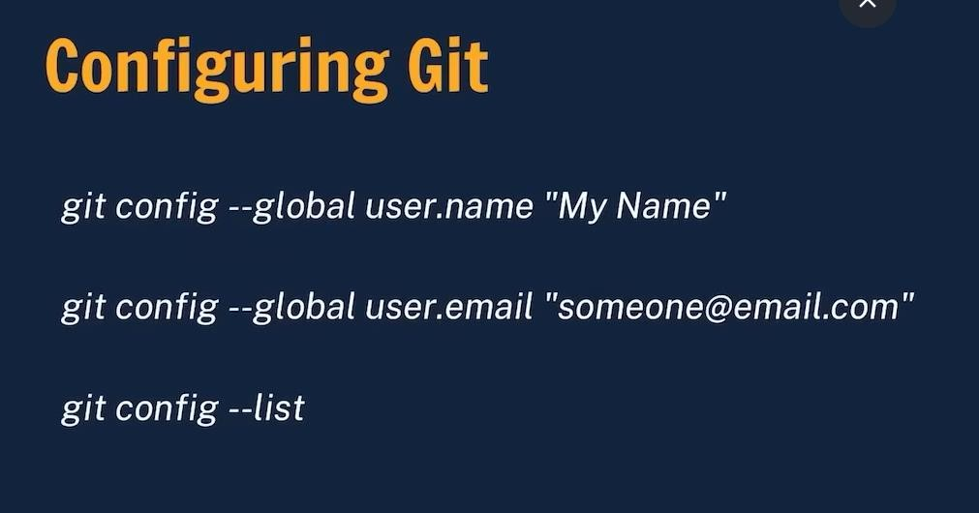

Clone & Status Command

- What is git clone:-
Command :--
git clone https://github.com/username/project-name.git

git clone is used to copy an existing remote repository (usually from GitHub) to your local computer.
It downloads the entire project with its files, history, and branches.

- git status Command:-
Command :- git status
git status shows the current state of your working directory and staging area. It tells you:
- Which files are modified
- Which files are staged
- Which files are untracked
- Whether your branch is up to date
- Cd Command :--
cd stands for Change Directory. It is used to move from one folder (directory) to another in the command line (Terminal / Git Bash / CMD).
  - Go inside a folder
cd "Folder Name" Ex : cd "git titorial"
  - Go back one directory ( Maghachya file Madhie janya sathie)
cd ..
  - Go to home directory cd ~ (Use home directoryC:\Users\kamb)
~ represents the home folder of the current user.
Command : cd ~
iii) Go to root directory Command : cd / Example :
PS C:\Users\kambl\Desktop\git titorial> cd /
PS C:\>
PS C:\> cd "C:\Users\kambl\Desktop\git titorial" PS C:\Users\kambl\Desktop\git titorial>
- ls Command Purpose :-
The ls command is used to display files and folders present in the current directory.
ls -Force Command (Show all files (including hidden files)

Step After the File Modify ( Clone from the Git Hub ) 3)
- git status ( shows the current state of your working directory )
- git add .
git add . is used to add all new and modified files from the current directory and its sub-directories to the staging area.
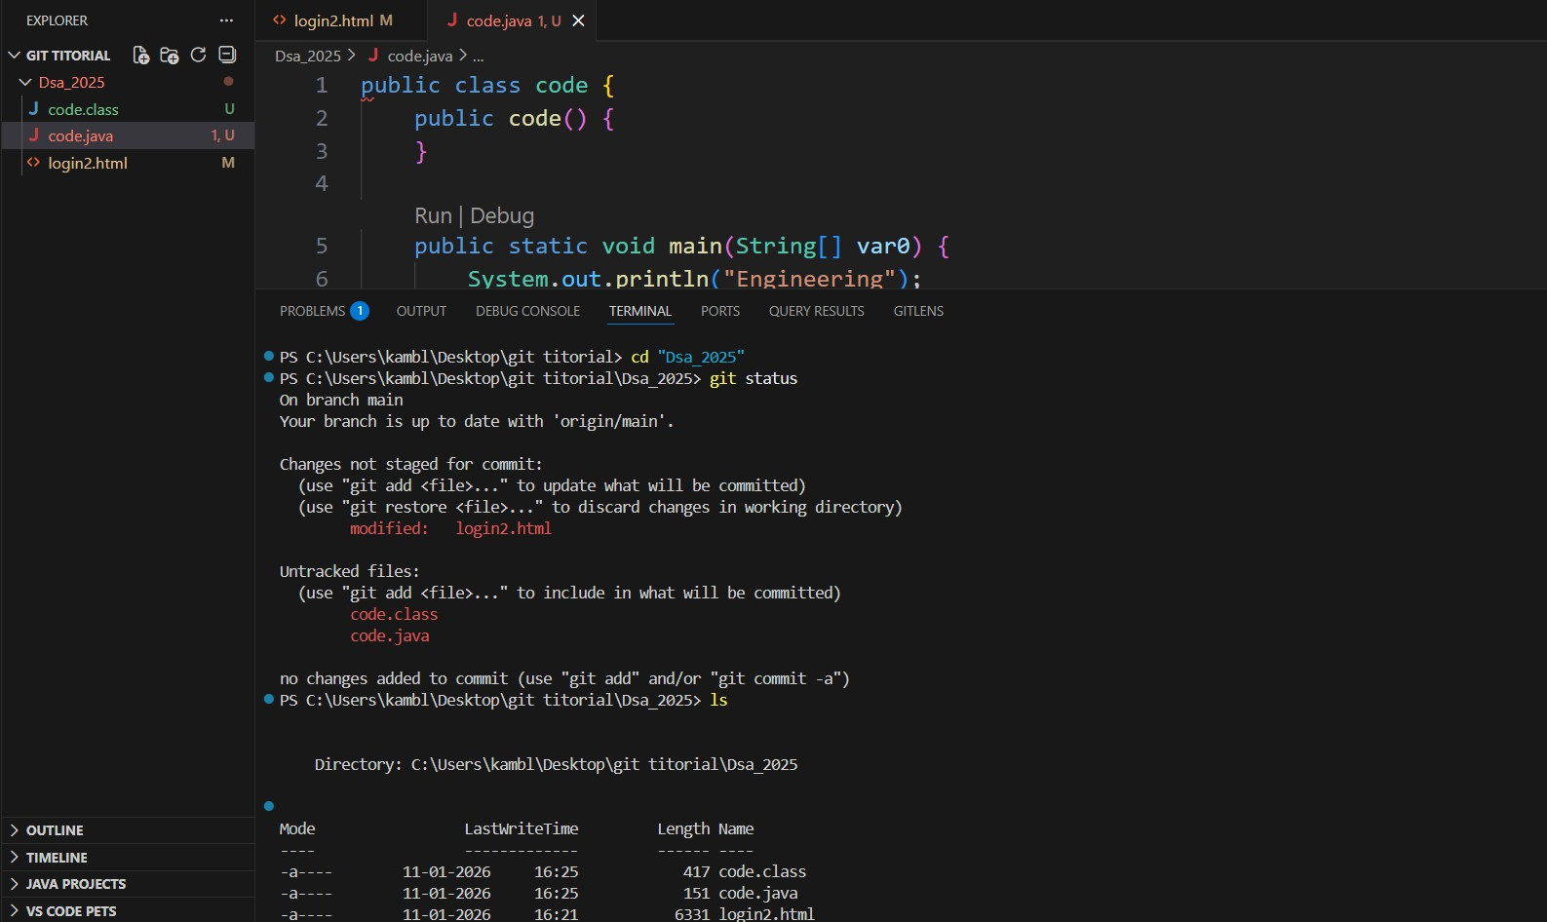
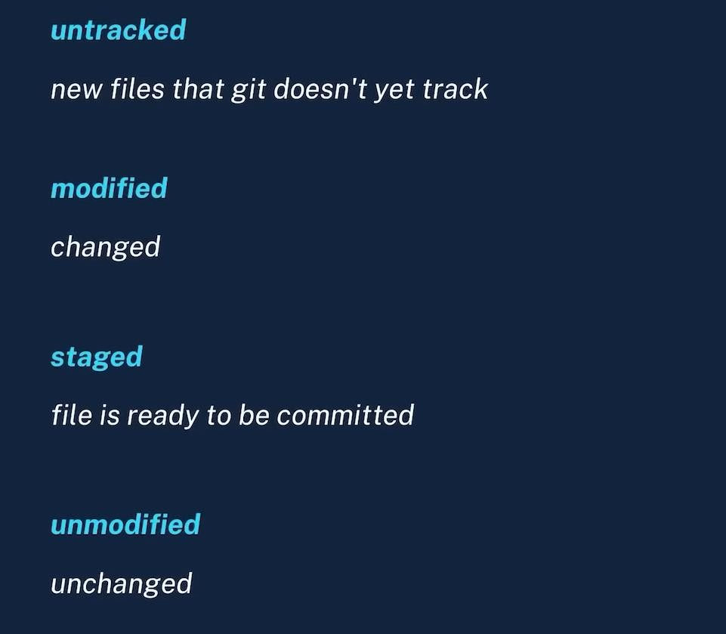

Add & Commit
  - What is git add .

git add. is used to add all new and modified files from the current directory and its sub-directories to the staging area.

    - If You Want to Add the single File only give command
git add File name ( Ex: git add code.java )
    - If you want to add All Files from folder give command
git add . 2 ) What is a commit
A commit is a record (snapshot) of changes you have made to your project. It saves the current state of staged files into Git history

Command : git commit -m "some message"

- commit → saves the changes
- -m → message
- "some message" → description of what you changed

Push Command Final Command ( From Vs code to Git Hub )
What is push Command
Push means uploading your local commits to the remote repository (GitHub). Simple meaning:
Local → GitHub Command syntax :-
git push origin main
- git push → send changes to remote
- origin → remote repository name (default)
- main → branch name

6 ) Step To Remove the Git Hub credentials Authentication
FINAL & GUARANTEED FIX (do exactly this)

STEP 1: Remove cached GitHub credentials (MOST IMPORTANT) Method A (Best – GUI way)
- Press Windows + R
- Type:
- control keymgr.dll
- Open Windows Credential

- Find entries starting with:
  - git:https://github.com
- Delete ALL GitHub-related entries
- Close everything

Steps To Verify Git identity / configuration (just to confirm)
git config --global user.name ( Enter in the git Bash Shell) git config --global user.email

I Push One File to One Git Hub Repository( Name is -Regression File ( Time : 1.47) )

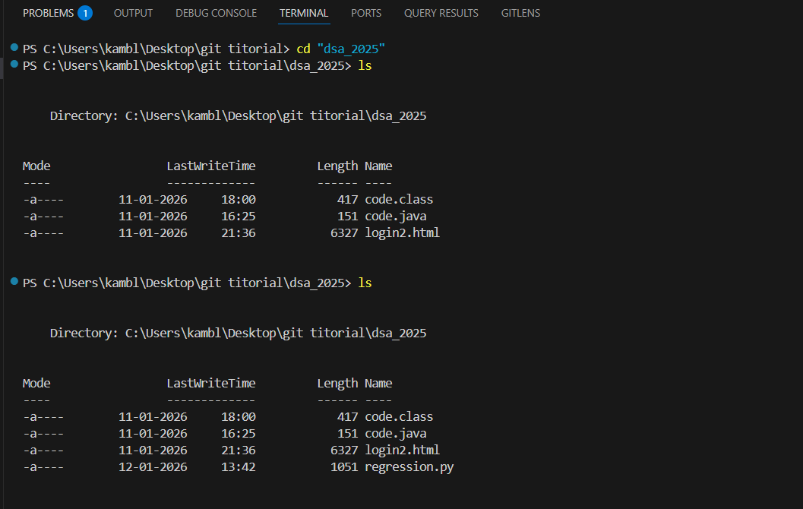
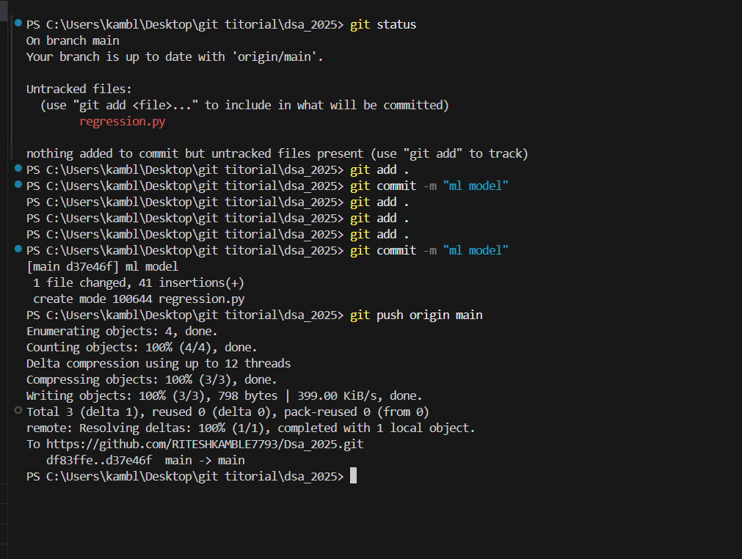

- If You Want To Create Folder with Terminal In Vs_code Terminal ( go To Vs terminal & Enter Command )

I) Create one folder
mkdir foldername
Example: mkdir regression II ) Create folder with space in name
mkdir "File Name"
Ex : mkdir "Java Programs"
III ) Create multiple folders at once
mkdir src test docs

10 ) Step To Make Local Repository To Git Repository ( For Push New Foder/Files From Vs To Git Hub website )

- Check Hidden Files With Command : ls -Force
- If File/folder Are Not Git repo Then use Command To Make Git Repo : git init ( Start git for Push Files )

Caution While Push the File From Vs To Git Repository
If th Git Hub repo url Already Exist In Local File (Vs Code ) &You try to Push Saperate New Folder in same git remote repository that alredy exist (That Not Exist In folder of git repository)
Then New Folder Past into folder of git & then push new file.

Rules While Push the File From Vs to Git Hub

THE CORE RULE YOU MISSED (Very Important)
ONE GitHub repository = ONE .git folder (ONLY at root)
You CANNOT push two separate folders independently to the same repo.

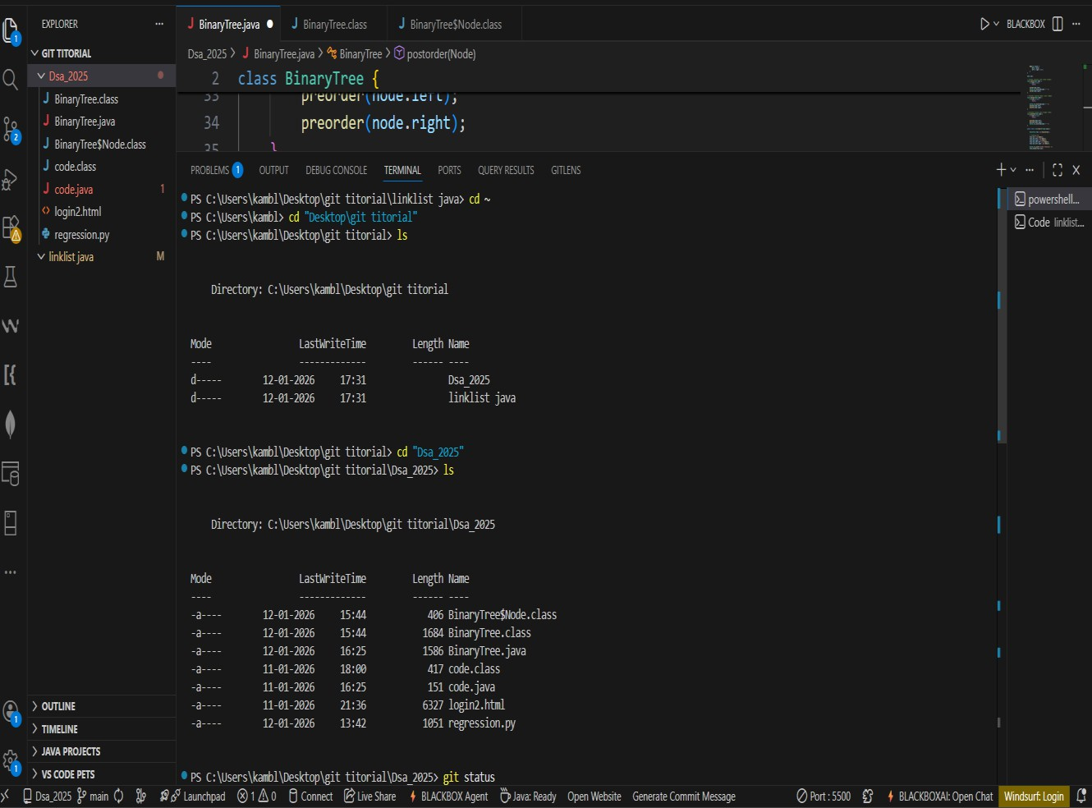

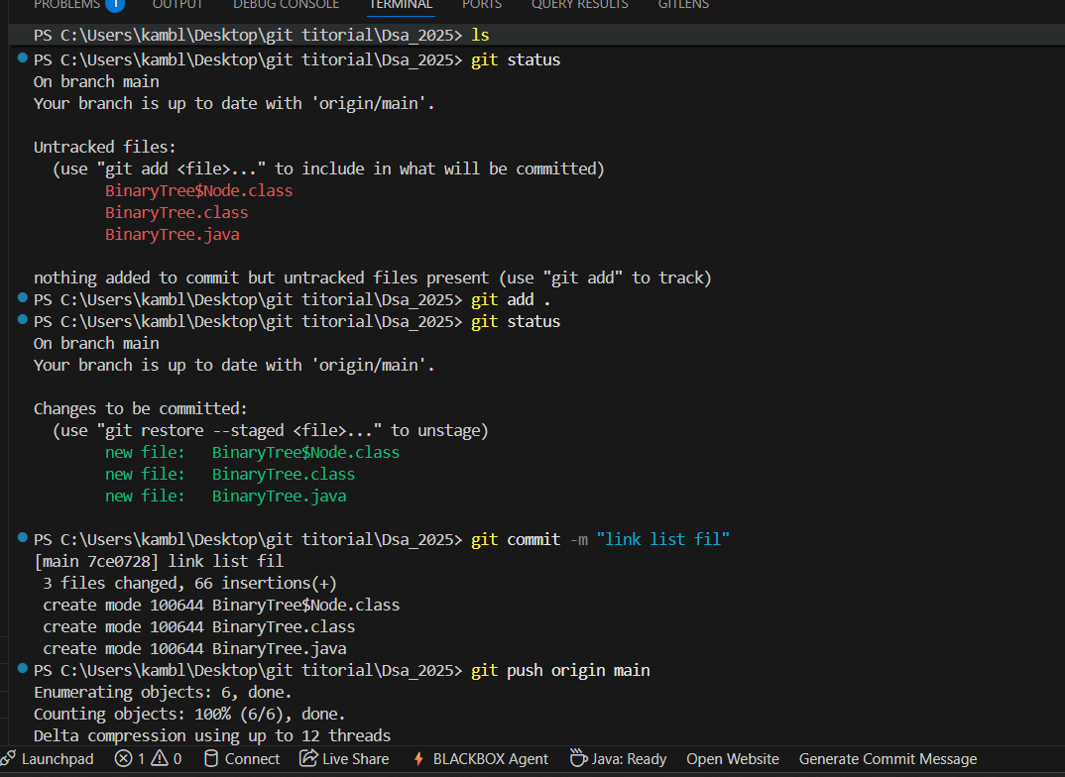

Init Command ( While Use When Push File From Vs to Git hub )

  - ) git init command
git init is used to create a new Git repository in a folder. Git creates a hidden .git folder
That folder stores all version history, commits, branches, config After this command, the folder becomes a Git-tracked project.

) git remote add origin <link>
It connects your local Git repository to a remote repository on GitHub.

) git remote -v
What it do:
Verifies the remote connection Example output
origin https://github.com/username/repo.git (fetch) origin https://github.com/username/repo.git (push)

) git branch
Shows all local branches
Highlights the current branch Example output :
    - master
    - main

V) git branch -M main
Renames the current branch to main Why this is needed
GitHub’s default branch is main
Older Git versions use master Vi ) git push origin main Or

git push -u origin main ( Final Step )
Uploads your local commits to GitHub

) Step To Add README.md File For “ massage “
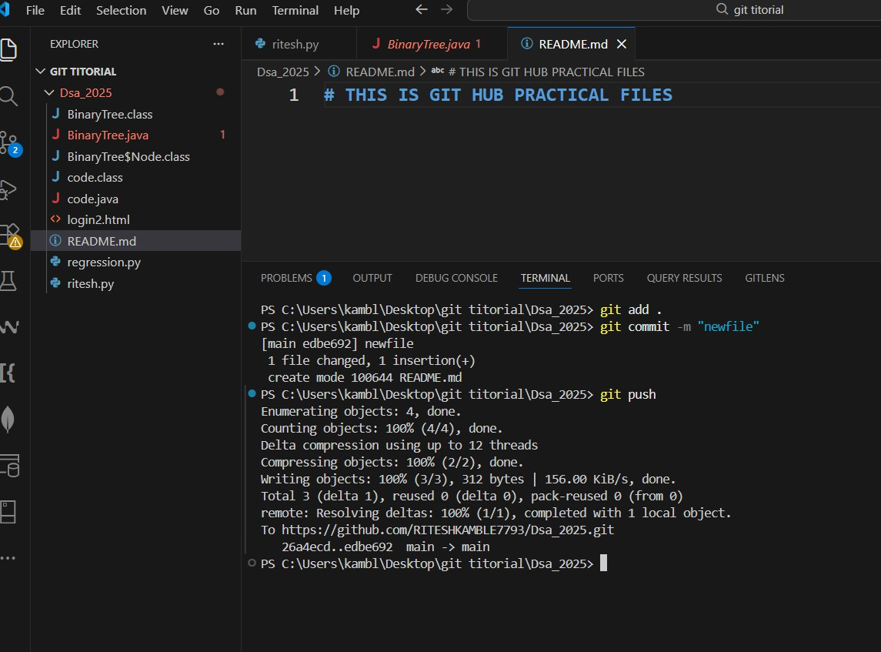

- )Summary: Difference between Git & GitHub
  - Git is a version control system used to track changes in files on your local machine.
It works offline and manages code history using the .git folder.
  - GitHub is a cloud-based platform that hosts Git repositories online.
It helps with backup, sharing, and team collaboration.
👉 Git = tool
👉 GitHub = service using Git

16 ) Branch Commands .

git branch
Purpose: Check branches
  - Lists all local branches
  - shows the current branch

) git branch -M main
Purpose: Rename branch
  - Renames the current branch to main
  - Used to match GitHub’s default branch
  - -M forces rename if needed

) git checkout <branch-name>
Purpose: Navigate (switch) branch
  - Moves you from one branch to another
  - Does not create a new branch

) git checkout -b <new-branch-name>
Purpose: Create + switch branch
  - Creates a new branch
  - Immediately switches to it
  - Most commonly used command

) git branch -d <branch-name>
Purpose: Delete branch
  - Deletes a local branch
  - Works only if the branch is already merged

Pull Command
Commnad : git pull origin main
git pull downloads changes from a remote repository and merges them into your current branch.

( this command used when we merge the two branch file &we want to download from remote to local )

- Undo changes Command
  - You edited a file but want to discard changes.

git restore <file>
Example : git restore ritesh.html
  - Undo ALL unstaged changes
Resets all modified (unstaged) files

git restore .
  - Undo the LAST commit (keep changes)
You committed by mistake but want to edit and recommit.
git reset --soft HEAD~1

19) Steps To Create new branch in one command In Vs code In terminal

Command :--
git checkout -b branch-name
Example:--
git checkout -b GIT-EXAM

20) If You Switch to existing branch & Push File

Command :--
git checkout <branch-name>
Example :--
git checkout GIT-EXAM

21)If Push branch to remote repository

Command :-
git push origin branch-name

Example:
git push origin Branch name

22) If you Check Branch List ( Check in terminal in vs with command )

Command :-
git branch

